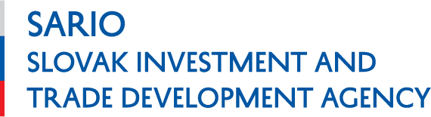
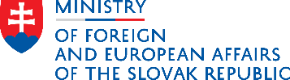

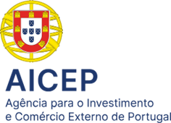
Green & Smart Futures: Slovak-Portuguese Business Forum, November 27th 2025
“Where innovation meets sustainability.”
When: 27th November 2025, 9:00 – 14:00
Where: Unicorn Factory Lisboa, Beato Innovation District, Entrance 5 - Unicorn Stage
Av. Infante Dom Henrique, 141, 1900-500 Lisbon
Sectors: Smart Cities, ICT, Green Technologies, Biotech/Health

PROGRAMME
9:00 Registration
9:30 Opening Ceremony
9:35 Presentation on Slovak Business and Investment Environment by Director General of SARIO, Mr. Robert Šimončič
9:50 Presentation on Portuguese Business and Investment Environment by Chairwoman and CEO of AICEP, Ms. Madalena Oliveira e Silva
10:05 Opening statement by the President of the SR Peter Pellegrini tbc
10:10 Opening statement by the Representative of the Government of the Portuguese Republic
10:15 MoU Signing Ceremony
10:25 Presentation by EXIMBANKA SR tbc
10:40 Presentation by Banco Português de Fomento tbc
10:55 Coffee Break and Networking
11:30 B2B Meetings
13:00 Networking Lunch in A Praça Hub (Beato Unicorn Factory)
14:00 End of the Event
Register by 21th November 2025: https://www.sario.sk/sk/form/registration-green-smart-futures

